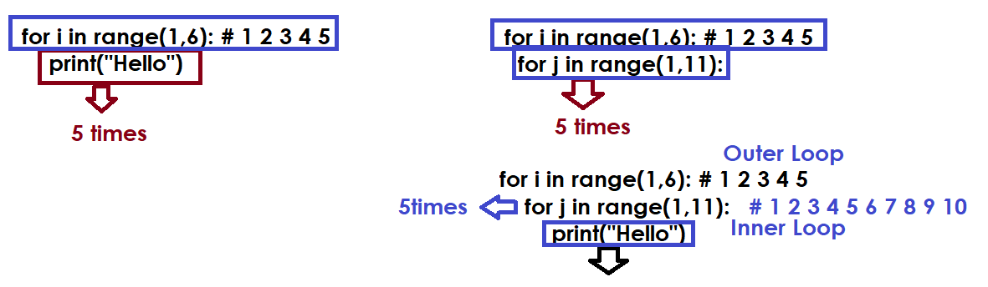

Write a program to generate the following output (OR) generate tables (1-10).

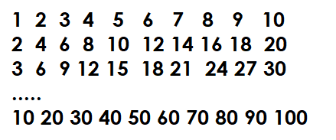

for num in range(1,11): # 1 2 3 4 5 6 7 8 9 10
for i in range(1,11): # 1 2 3 4 5 6 7 8 9 10
p=num*i
print(p,end=' ')
print()

# Write a program to find prime numbers between 2 to 100

for num in range(2,101): # 2 3 4 5 6 7 8 9 10 11 ...
c=0
for i in range(1,num+1):
if num%i==0:
c=c+1
if c==2:
print(num,end=' ')

Output
2 3 5 7 11 13 17 19 23 29 31 37 41 43 47 53 59 61 67 71 73 79 83 89 97

Example:
# Write a program to generate factorials of all
# numbers from 1 to 10

for num in range(1,11): # 1 2 3 4 5 6 7 8 9 10
fact=1
for i in range(1,num+1):
fact=fact*i
print(f'{num}={fact}')

Output
1=1
2=2
3=6
4=24
5=120
6=720
7=5040
8=40320
9=362880
10=3628800

